|  |  |
| --- | --- |
| **XX Community Sponsorship Group** |  |

***Welcome to your new home!***

This booklet provides you with information about your home and community, and sets out how we would like to help you settle in and be part of the local community. This booklet will also highlight what will need to be done in your first few weeks in Ireland.

We want you to feel safe, secure and relaxed. At any time, if you are uncomfortable with what we are proposing, please say so. At any point, please say if there is something you want to do or would rather not do.



**Section 1: Introduction to your Community Sponsorship Group (CSG)**

Our Team:

Emergency Services :

Community Sponsorship Group (CSG):

**Section 2: Your new home**

Your home:

Budget

How to get a Sim card

Basic budget

**Section 3: Your New community**

3.1 Transport:

3.1.1 General transport information:

3.1.2 Specific transport

3.2 Local shops

3.2.1 Grocery Shopping

1) Newsagents:

2) Supermarkets:

3) Ethnic food stores:

3.2.2 Non grocery and others

4) Pharmacy:

5) Barber

3.3 Doctor & Dentist

3.4 Local Amenities

1) Local parks:

2) Community Gardens

3) Public Library

4) Places of worship:

**Section 4: First Few Weeks in Ireland**

4.1 Register with local Immigration Office:

4.2 Register with the Department of Social Protection:

4.3 Register with Revenue

4.4 Register at INTREO office

4.5 Get in contact with your GP

4.6 Apply for medical card

4.7 Apply for housing support

4. 8 Apply for travel documents

4.9 Open a bank account

**Section 5: Raising Issues or Concerns**

# 

# Section 1: Introduction to your Community Sponsorship Group (CSG)

Who we are and what support we can offer.

## Our Team:

We are here to help you to take your first steps in Ireland. You’ll find below our contact details (how to reach us) and area of expertise.

|  |  |
| --- | --- |
| Insert photo | (lead sponsor)  08  What I’ll help you with: |
| Insert photo | (Secondary sponsor)  Speaker phone with solid fill 08  What I’ll help you with: |
| Insert photo | Speaker phone with solid fill 08  What I’ll help you with: |

|  |  |
| --- | --- |
| Insert photo | Speaker phone with solid fill 08    What I’ll help you with: |
| Insert photo | Speaker phone with solid fill 08  What I’ll help you with: |
| Insert photo | Speaker phone with solid fill 08    What I’ll help you with: |
| Insert photo | Speaker phone with solid fill08  What I’ll help you with: |

In case of personal emergency contact the lead sponsor first.

## Emergency Services :

If you need the emergency services, including the police, the fire brigade or an ambulance, **call 999 or 112**. (In Ireland, we call our police force *An Garda Síochána* [*[ənˠ ˈɡaːɾˠd̪ˠə ˈʃiːxaːn̪ˠə*](https://en.wikipedia.org/wiki/Help:IPA/Irish) or the *Gardaí* [*[ˈɡaːɾˠd̪ˠiː]*](https://en.wikipedia.org/wiki/Help:IPA/Irish)*[1]*)

When to call?

Only call 999 or 112 in genuine emergencies. For example, when yours or someone’s life, health, property or the environment is in danger.

## Community Sponsorship Group (CSG):

As a group, we are here to help you take your first steps in Ireland, and in your new neighbourhood. You can contact us as often as necessary, and we will make sure to reach out to you very regularly in the first weeks and until you find your feet. We will guide you through all important steps, including administrative, that you will need to take after you arrive. We are here to show you around your neighbourhood. We will also help you feel welcome and included by linking you in with social activities on offer.

When you arrive in Dublin airport, some of us will be there to welcome you and take you to your new home. We will have bought some basic food for you and during the first couple of weeks we will be available to show you around your local neighbourhood and assist you with all your first step administrative tasks, including opening up a bank account, registering for government support, and sourcing language classes. Based on your interests, we will also direct you to community groups so that you can start to get to know people (other than your sponsorship team).

[**Swift integration app**](https://theopencommunity.ie/swift-integration/)**:**

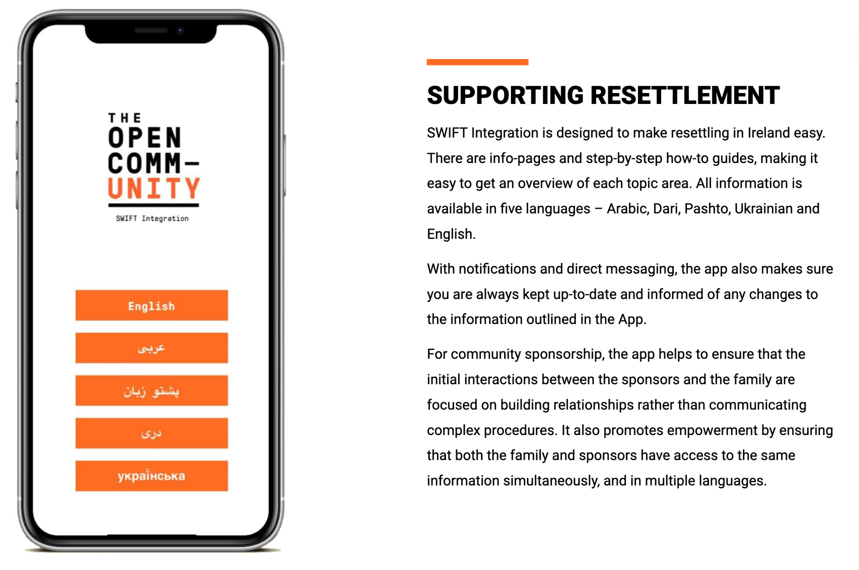

# 

# Section 2: Your new home

## Your home:

INSERT PICTURE OF THE NEW HOME

Your address is :

|  |  |
| --- | --- |
| Insert map of Ireland | Pin location of accommodation |

On arrival you will get a tour of your accommodation and we will explain how everything works as well as the rules of the house. Feel free to ask as many questions as you wish. You will pay a monthly rent of €XX per month plus a contribution towards utilities, including electricity and gas/oil, internet, etc. You will be provided with the rent and basic allowance by the group from their fundraising activities until your social welfare payments commence, including your Housing Assistance Payment (HAP) and Job seeker’s allowance.

## Budget

We will make sure that you have food and other necessities in the house on the day you arrive.

We will give you an envelope with some money for your first month, until you have set up a bank account. This money is to be used to cover your rent, food and other basics that you will need. Once your bank account is up and running, we will deposit more funds to cover the initial period until your social welfare payments commence.

In addition to food and other supplies, you will probably want to get an Irish Sim card for your phone.

### 

### How to get a Sim card

* Choose a phone supplier (in Ireland the main phone providers are : Vodafone, Eir, Three)
* Go to the shop and ask for a ‘Pre Pay’ plan (€20) and a Sim card ( €10)

### Basic budget

On a typical week, once you are fully registered for Government support, you’ll receive about a €XX job seekers’ allowance per week from your social welfare office (until you find a job). To give you an idea, here is a basic budget:

Rent: € XX per month

Utilities: €XX per month

Core expenses: €XX

* Groceries (food): €XX
* Other supplies (Shampoo, cleaning products etc.): €XX
* Phone (€XX p/m):€XX
* Bus/public transport: €XX

**TOTAL €XX**

Possible extra weekly expenses :

* Tea/coffee/soft drink in café: 1 cup of coffee in a coffee shop can be up to 5€
* Sandwich in café: 1 sandwich around 10€
* Barber: for 1 male hair cut expect 15€
* Cigarettes: 1 pack 15€
* Clothes: 40 €
* Cinema: 1 ticket is about 12 €
* Pharmacy : 10 €

# Section 3: Your New community

## 3.1 Transport:

There are different types of public transport in the locality:

1. Bus
2. Train (as applicable)
3. Other

General information and details on each specific transport are given below

### 3.1.1 General transport information:

You may use Google Maps to guide you through your journey and show you what’s the best option in real time.

We recommend that you get a Leap Card which you will use **to pay for some public transport journeys. You should check this possibility.**



You can buy this card (€5) at in any newsagents (small grocery stores i.e SPAR). Once you have a bank account, you’ll be able to top up online through the Leap card app.

The fare depends on your destination. You can find sample fares [HERE](https://about.leapcard.ie/about/fares-discounts)

Note that both English and Irish languages are used on public transport

### 3.1.2 Specific transport

​​

## 3.2 Local shops

There are different types of shops in your neighbourhood.

1. Newsagents
2. Supermarkets
3. Ethnic food shops
4. Pharmacy
5. Barber

You can buy first necessity Items, including some in Newsagents - you can also top up your Leap Card. You can do your grocery shopping in Supermarkets. You can get medicine in the pharmacy and for a haircut, you can go to the barber. Details on each and address are given in sections below.

### 3.2.1 Grocery Shopping

You can buy food (grocery) in all sorts of shops:

#### Newsagents:

The smaller shops are called ‘newsagents’- They are for first necessities as they tend to be more expensive (!).

Note that you can top up your Lead Card in Newsagents.

Newsagents may have different names; This include: SPAR; CENTRA; COSTCUTTER



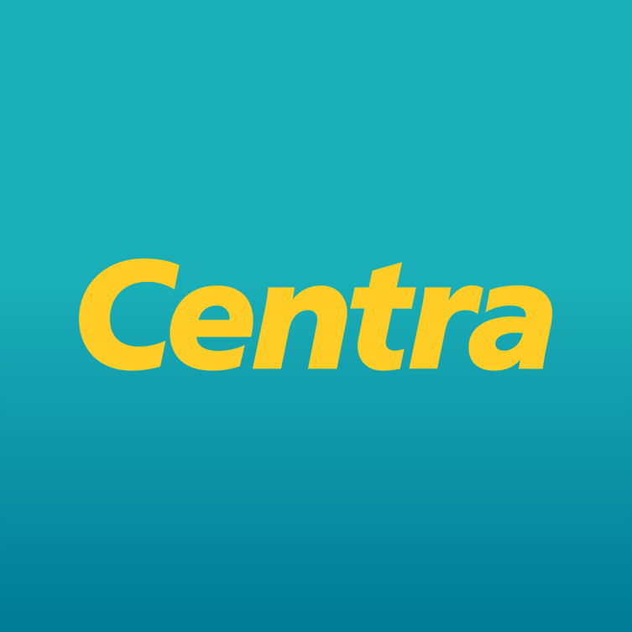 

#### Supermarkets:

Supermarkets are bigger and generally cheaper, you can find most of what you may need in terms of food. You may need to go a little further to find one.

Note that you can also buy your toiletries (Shampoo; soap etc.) and cleaning supplies (Toilet paper; Washing powder etc.) there.

Supermarkets have different names and some are cheaper than others. Names of supermarkets include:



#### Ethnic food stores:

Regular supermarkets tend to cater for the general Irish population. It is possible that some items you may require for your own cooking (i.e Spices; Halal meat etc.) are not available in regular shops. In that case you may want to go to an ethnic food store

Your closest Ethnic food store is:

### 3.2.2 Non grocery and others

#### Pharmacy:

You can buy medicine in pharmacies. While you can buy some medicine over the counter, in certain cases you will need a prescription (paper note) from your doctor (GP)

* Medicine available over the counter: These are available without a prescription from your doctor for any occasional and superficial illness, you can however ask advice of the pharmacist. This includes: pain killers; cough syrups; eyes/nose/ear drops; allergy pills, stomach pills, plasters for superficial cuts and burns etc.
* Prescriptions: For stronger medicine to cure more serious or chronic illness you will need a note from your doctor (prescription). The pharmacist will not be able to supply the medicine without a prescription.

Your closest pharmacy:

#### Barber/Hairdressing Salon

To get a haircut you can visit one of your local barbers/hairdressing salons.

### 3.3 Doctor & Dentist

Your doctor (General Practitioner; GP) is:



Your dentist is

### 3.4 Local Amenities

#### Local parks:

#### Community Gardens

A community garden is an urban piece of land cultivated by a collective of people/ community. If you join (usually free) you can contribute to cultivating it.

#### Public Library

Public libraries allow you to register and borrow books and films for free. Your closest library is

To register, you:

- Fill out the application form online or at any branch.

- Provide proof of your identity and of your address.

#### Places of worship:

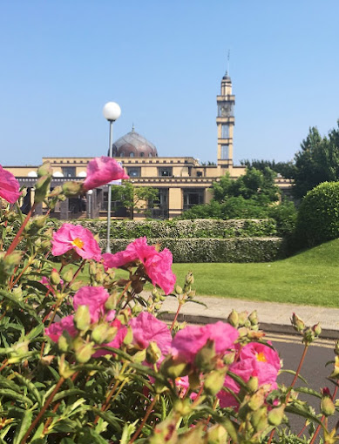

**Islamic Cultural Centre of Ireland:**

Address: 19 Roebuck Rd, Roebuck, Dublin 14, D14 YD91

**Section 4: First Few Weeks in Ireland**

In the first couple of weeks there are a number of things that need to be done in regards with administration. We are here to help you throughout. You’ll find the explanation below on each of those steps.

1. Register with local immigration office
2. Register with the department of social protection (getting your PPS number)
3. Register to Revenue
4. Register to INTREO office (Social Welfare)
5. Get in contact with your GP (Doctor)
6. Apply for medical card
7. Apply for Housing support (HAP)
8. Apply for Travel Documents
9. Open a bank account

## 4.1 Register with local Immigration Office:

Once you arrive and get your declaration of refugee status, you’ll need to register online to make an appointment with the Immigration Office.

Address of immigration office : 13/14 Burgh Quay, Dublin, D02 XK70

## 4.2 Register with the Department of Social Protection:

Your Personal Public Service (PPS) number is a unique reference number that helps you access social welfare benefits, public services and information in Ireland.

An online PPS Number application service is available at [mywelfare.ie](https://services.mywelfare.ie/en/topics/identity-services/personal-public-service-pps-number/)

You will need to upload photos or copies of:

* your identity document
* evidence of why you need a PPS Number and
* your evidence of address

To get your Public Service Card (PSC) you will need to do in-person registration. The Department of Social Protection will send you a letter with your SAFE registration appointment. SAFE registration takes about 15 minutes to complete and usually takes place in your [local Intreo Centre](https://www.gov.ie/en/directory/category/e1f4b5-intreo-offices/) (Irish Public Employment Service). You must bring certain documents with you to your appointment to prove your identity and address. You should also bring the letter you got confirming your appointment and, if you have one, your mobile phone.

## 4.3 Register with Revenue

To create your basic MyGovID account, visit [MyGovID.ie](https://www.mygovid.ie/en-IE/HowDoISignUp), enter your email address, create a password and click ‘Register now’. A code will be sent to your email address which you will need to enter on screen to complete your basic account registration.

Once you have activated your MyGovID account, you can log into your basic account. You will see a list of online services including MyWelfare services.

You can also log directly into MyWelfare using your MyGovID.

## 4.4 Register at INTREO office

You are entitled to the [jobseeker’s allowance](https://www.citizensinformation.ie/en/social-welfare/social-welfare-payments/unemployed-people/jobseekers-allowance/). In order to receive it you must contact your local Intreo office.

Address:

## 4.5 Get in contact with your GP

Contact your GP (doctor) to get an approval letter. You will need it to apply for your Medical Card.

## 4.6 Apply for medical card

You can apply online for a medical card on [mymedicalcard.ie](https://www.mymedicalcard.ie/). This is the quickest method of getting the card.

## 4.7 Apply for housing support

You need to fill out a [Social Housing Support](https://www.hap.ie/) (HAP) application form which is available from your [local authority.](https://www.hap.ie/localauthorities/)

Phone number:

Email:

You then need to send your completed form to your local authority along with all of the documents needed to assess your case. You will get a list of these documents on your local authority’s Social Housing Support application form.

After agreeing a tenancy with your landlord, you and your landlord need to return the completed application form to your [local authority](https://www.hap.ie/localauthorities/) as soon as possible.

## 4. 8 Apply for travel documents

You are eligible to apply for travel documents. You apply to the Travel Document Unit of Immigration Services Delivery using the [travel document application form](https://www.irishimmigration.ie/wp-content/uploads/2022/06/Travel-Document-Form-June-2022.pdf). You can download the document on  [Immigration Services Delivery](https://www.irishimmigration.ie/) website

You should include the following with your completed application:

* 4 passport-size photographs, 2 of which are signed by a member of An Garda Síochána (Police)
* Fee of €80 - you should pay by bank draft or postal order, made payable to the Department of Justice.
* Passport or national identity card
* Permission letter allowing you to remain in Ireland

## 4.9 Open a bank account

You can open an account in any bank for your everyday banking needs. for example with a current account you can

* lodge (put) money such as your salary or social welfare payment into the account
* Take out money at ATM (cash machine)
* Use your debit card to make payments
* Transfer money to another account (irish or international)
* Pay bills

Once you have decided what type of account you want and in which bank, contact them and ask for an application form. You will have to provide proof of identity and address.

# Section 5: Raising Issues or Concerns

If there is anything that concerns you or if you have any issues, it is very important that you share this with us, either through one individual or as a group. These concerns might be of a personal nature, about any issues arising from your settling into your new community, or you might also have complaints about actions of the group or one individual**.**

If you feel comfortable to do so, you can raise it to the group, or to one individual which you feel most comfortable with. You have everybody’s details in this document.

If you DO NOT feel comfortable speaking with a member of the group, you can contact the Group’s Community Sponsorship Partner. Please find contact details below:

1. https://en.wikipedia.org/wiki/Garda_S%C3%ADoch%C3%A1na